**Introduction to Version Control**

**Questions/Assignment**

https://docs.google.com/document/d/1IIhAduVJYiJ6Fp_BMoLyjrWj4QNpH0Wqu09FJkUgOFQ/edit?tab=t.0

Q1)Git Setup <https://confluence.atlassian.com/bitbucket/set-up-git-744723531.html>

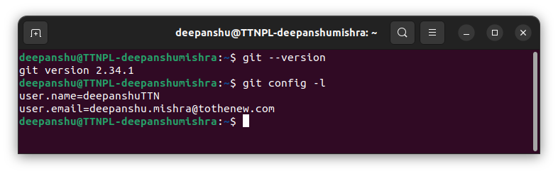

Q2)Initialize a Git Repository

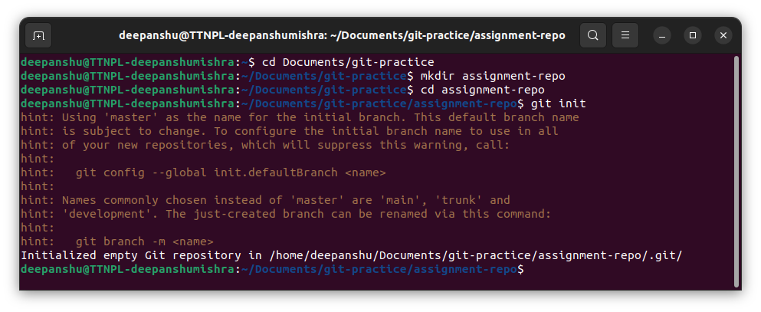

Q3)Add files to the repository

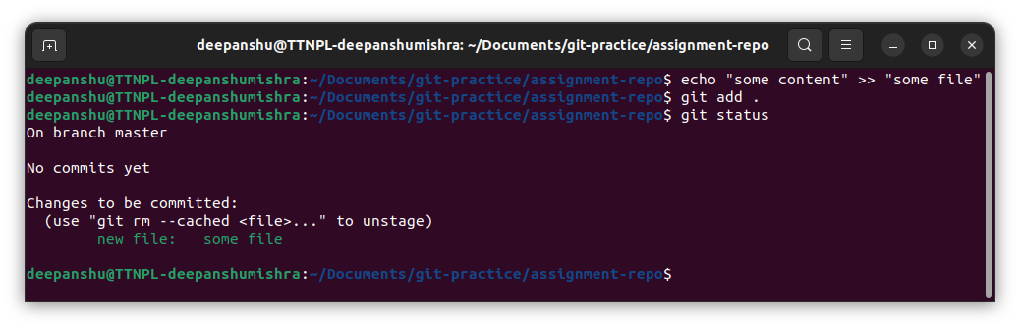

Q4)Unstage 1 file

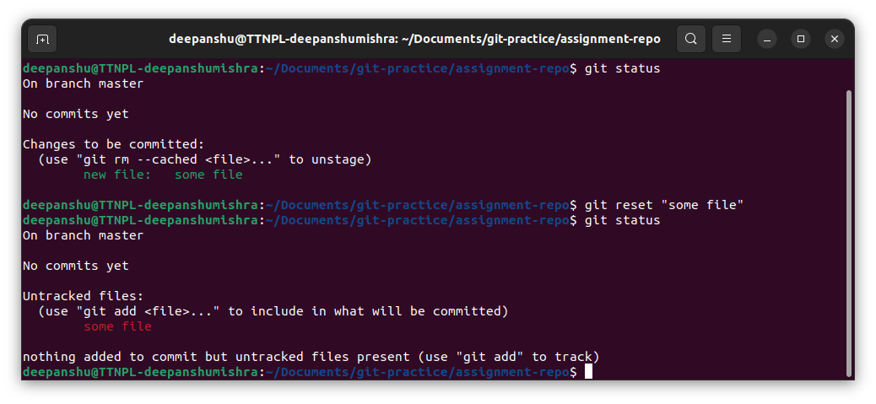

Q5)Commit the file

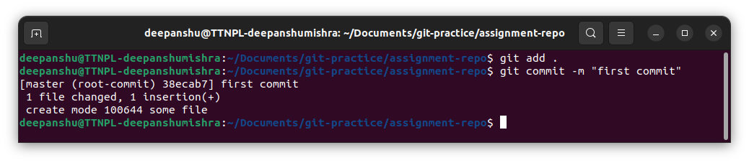

Q6)Add a remote

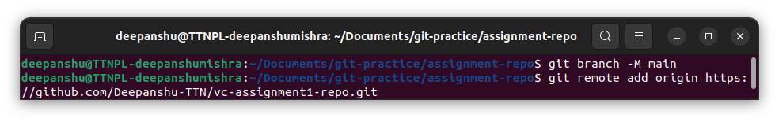

Q7)Undo changes to a particular file

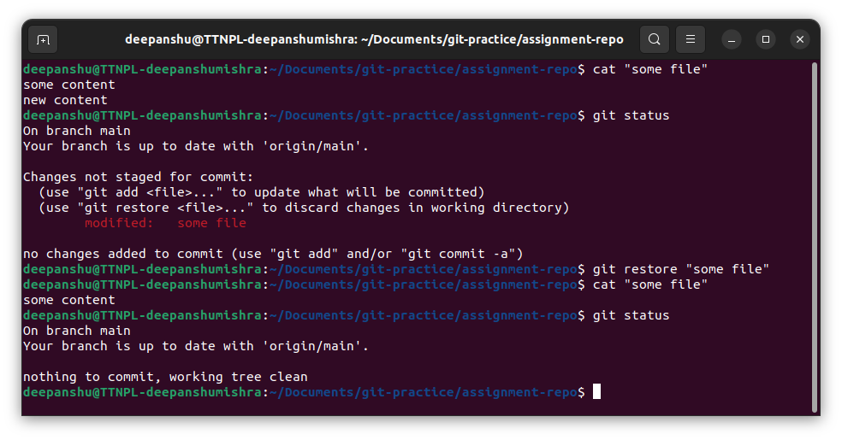

Q8)Push changes to Github

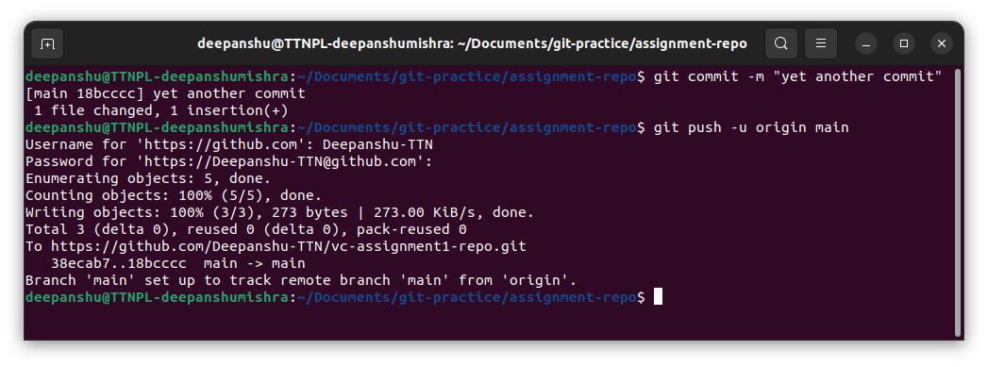

Q9)Clone the repository

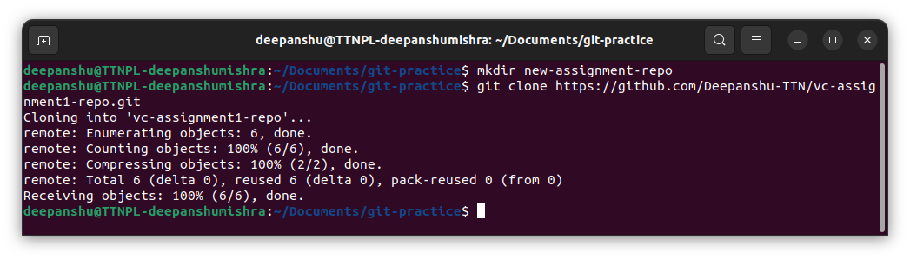

Q10)Add changes to one of the copies and pull the changes in the other.

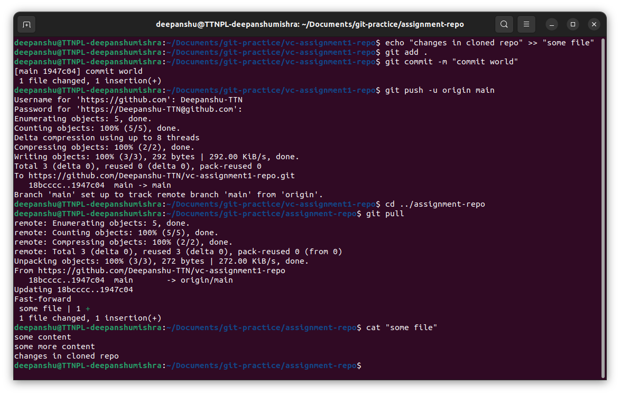

Q11)Check differences between a file and its staged version

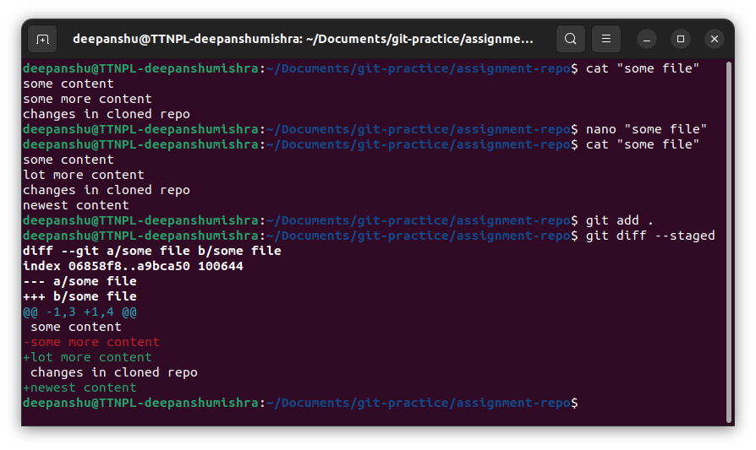

Q12)Ignore a few files to be checked in

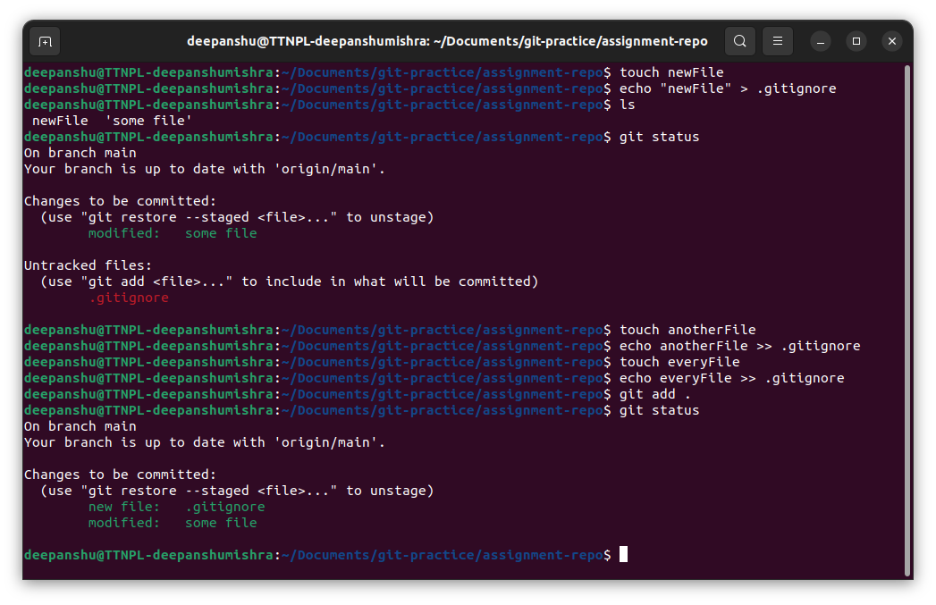

Q13)Create a new branch

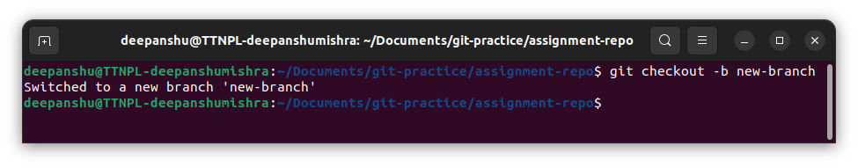

Q14)Diverge them with commits

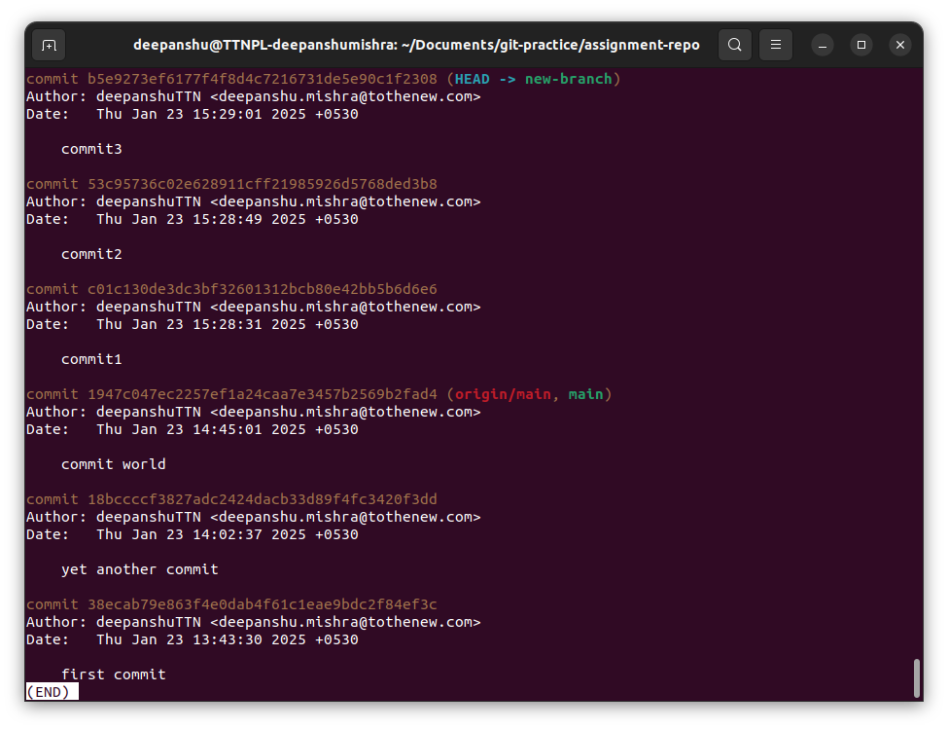

Q15)Edit the same file at the same line on both branches and commit

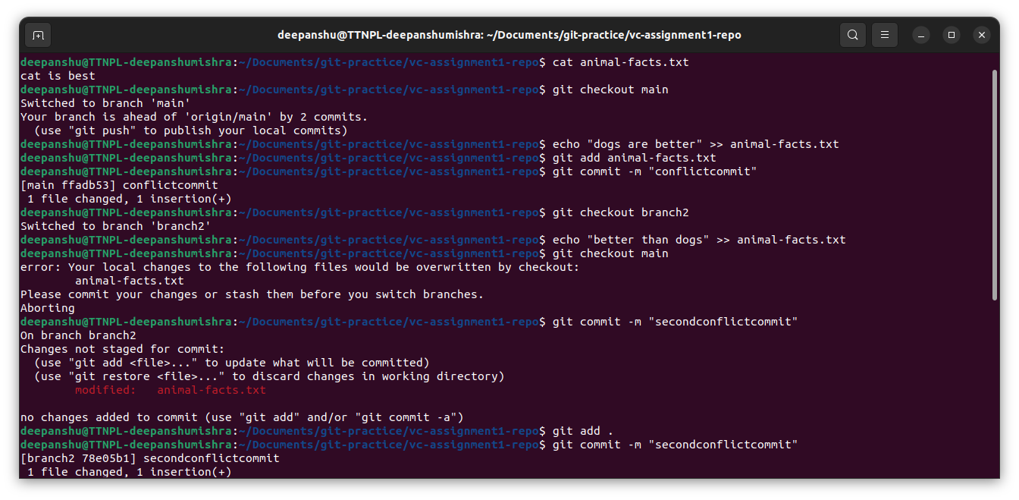

Q16)Try merging and resolve merge conflicts

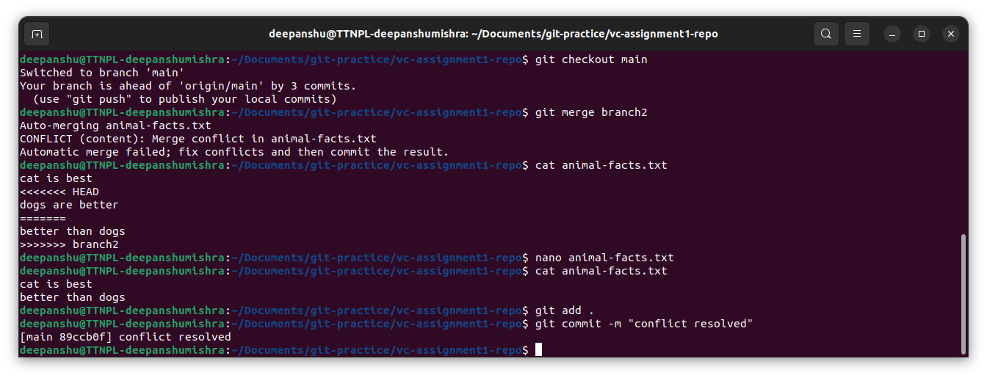

Q17)Stash the changes and pop them

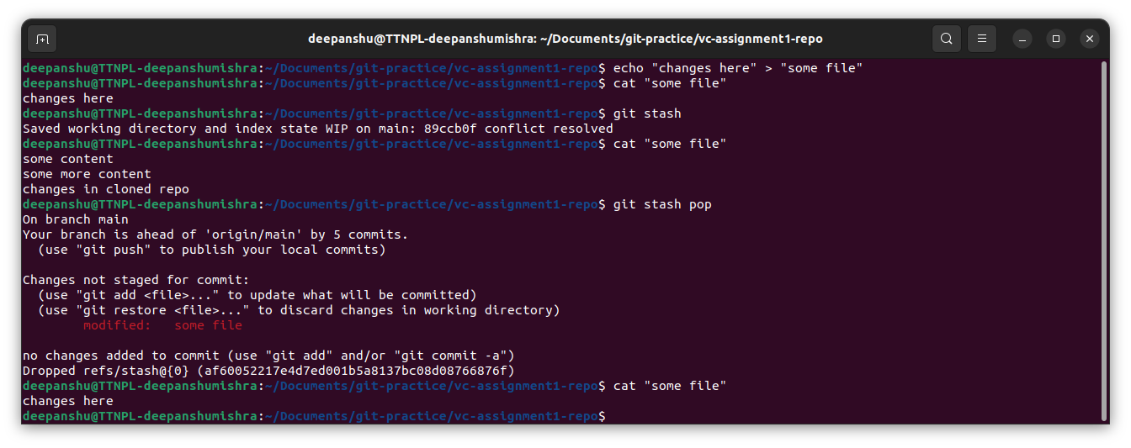

Q18)Add the following code to your .bashrc file : color_prompt="yes" parse_git_branch() { git branch 2> /dev/null | sed -e '/^[^*]/d' -e 's/* \(.*\)/(\1)/' } if [ "$color_prompt" = yes ]; then PS1='\u@\h\[\033[00m\]:\[\033[01;34m\]\W\[\033[01;31m\] $(parse_git_branch)\[\033[00m\]\$ ' else PS1='\u@\h:\W $(parse_git_branch)\$ ' fi unset color_prompt force_color_prompt

